Haloloop 2018

Contents

**1.1** **Background** 3

**1.2** **MinGW Work environment** 3

**1.3** **Test files** 3

***1.3.1*** ***Feb2-2001sgp*** 4

***1.3.2*** ***Jun24-2001sgp*** 4

***1.3.3*** ***Single-im: 12 images, mixed from TSI:*** 4

***1.3.4*** ***Parametrization*** 6

**2** **Feeding the Haloloop code** 7

**2.1** **Parsing the names of input files** 7

**2.2** **Input Parameters** 8

**3** **Image Preparations** 10

**3.1** **Importing images** 10

**3.2** **Variables for the current image** 11

**3.3** **Identifying the horizon circle** 11

**3.4** **Removing Distortions** 14

***3.4.1*** ***Ellipse to circle, and masking:*** 14

***3.4.2*** ***Removing the mirror distortion?*** 16

**3.5** **Finding the solar position in image** 19

***3.5.1*** ***References:*** 19

***3.5.2*** ***Testing in spreadsheet*** 21

***3.5.3*** ***Procedure for for solar position as used in haloloop:*** 22

**3.6** **Masking the shadow strip and the camera mount** 24

**3.7** **Local Sky Mat** 26

**3.8** **Camera aging and color corrections** 27

**4** **Halo Analysis** 31

**4.1** **Reference Images** 31

**4.2** **Average Radial Intensity: ARI and ARIVar** 31

**4.3** **Using Running Averages to analyze the ARI for Halo Indicators: EtaDerivMarkers** 32

**4.4** **Line fit to ARI: slope and intercept** 36

**4.5** **Relative Blue Ratio: ColorValue** 37

**4.6** **Defining the Parameter Space: Skytype criteria and halo criteria** 38

**4.7** **Multivariate Normal Distributions to assign Sky Type Scores and Halo Scores** 39

**4.8** **Test Results for Skytype Scores** 40

**4.9** **Test Results for the Halo Score in the test images** 42

**4.10** **The haloloop-scoring table** 45

**4.11** **Halo DOS** 48

**5** **Data Collection** 51

**5.1** **TSI images** 51

**5.2** **How to prepare a set of TSI images for a data run** 51

**5.3** **Time line** 54

## **Background**

* authors: Stephen Sorenson (6-2013 to 4-2014), Shelby Richard (5-2014 to 2015), Michelle King (2015-17), Morton Greenslit (2015-27), Sylke Boyd (6-2013 to present)
* Gained access to ARM site data and need to analyze for halos
* Using my own last version of haloloop (no cloud subtraction, no GUI) from July 6, 2015
* The documentation for that version is posted in the doc folder. I will make good use of it, but will have to redesign the program.
* No more use of Visual Studio, but will work in MinGW environment, and use makefile. Initial transition was successful.
* The modifications will address the following problems:
  + A much better way of controlling the input images
  + Use the image name to parse the date and time
  + Simplify the code!
  + Redo masking and orientation
  + Check if distortion removal still works.
  + Base the solar position on the geographical coordinates and UTC instead of an image property.
  + All criteria must be formulated in terms of relative coordinates since the mage sizes vary with time and location; pixel ranges are a bad reference!
  + I need more transparency in the output.
* Basically, this means to rewrite the entire code, but reuse the successful parts of the algorithms.

## **MinGW Work environment**

Older versions of haloloop were developed in a Visual Studio setup. This works, and documentation is included in the original haloloop folder from 2015.

However, I will proceed to set this up with MinGW. It is easier, and better transferable. The document “How to install a MinGw C++ environment.docx contains detailed instructions for a windows PC.

Reminder: SB office PC does not initialize opencv runtime libraries on opening a command terminal. If the following error message appear upon execution command:



You need to type the following shell command

export PATH=$PATH$:/c/opencv32/bin

After that, compiled programs should execute properly (within the current state of debugging, that is).

## **Test files**

Browsing by eye to find a few suitable examples:

### ***Feb2-2001sgp***

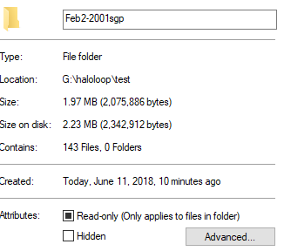

Figure 1. Screen grab for Feb2-2001 image properties

### ***Jun24-2001sgp***

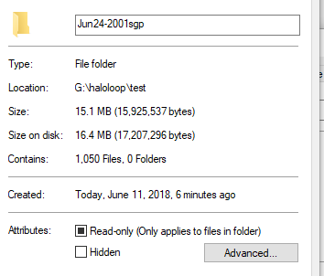

Figure 2. Screen grab for Jun24-2001 images

### ***Single-im: 12 images, mixed from TSI:***

Table 1. Visual reference for the twelve basic reference images

|  |  |  |
| --- | --- | --- |
| NSA, June 10, 2006, 1:45:00 UTC | NSA, June 10, 2006, 4:56:00 UTC | NSA, June 10, 2006, 15:18:00 UTC |
| SGP, May 14, 2001, 18:41:20 UTC | SGP, May 18, 2001, 0:12:40 UTC | SGP, May 18, 2001, 1:14:20 UTC |
| SGP, May 18, 2001, 15:55:40 UTC | SGP, May 18, 2001, 16:28:40 UTC | SGP, May 18, 2001, 21:04:00 UTC |

|  |  |  |
| --- | --- | --- |
| SGP, Sep 10, 2001, 17:26:00 UTC | SGP, Sep 10, 2001, 23:19:40 UTC | SGP, Sep 16, 2001, 20:32:40 UTC |

### ***Parametrization***

This folder contains four subfolders for each skytype, with examples across times and origins for each of the four sky types. These files will be the foundation for the halo and skytype probabilities.

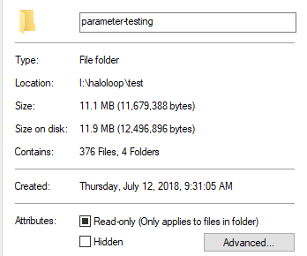

Figure 3. Screen grab of properties for parameter-testing

These images have different sizes, orientations, and exhibit different degrees of sensor exhaustion.

# **Feeding the Haloloop code**

## **Parsing the names of input files**

Criteria:

* The program should be able to work from a year folder, and descend into month and day folders in order to access the image files
* The program should read these requested files from a list, generated with the ls command.
* The program should take apart the strings of the file name into year, month, day, hour, min, sec.

Creating the list of image files to be processed: imagelist.txt



Replace the framed name with the names of folders you need to analyze. No slash behind the folder names!

The resulting file looks like this:

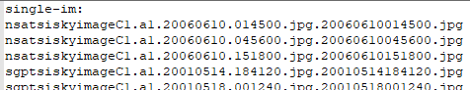

Figure 4. sample lines in imagelist.txt

Note that the name of the image list will be the core name for all files produced by haloloop during this run. It is best to remove the txt extension.

Internal process:

Haloloop asks for the name of the imagelist file, checks availability, and reads it line by line. It takes apart the file names, and generates a temporary file named

*haloloop-processlist.txt,*

which will be read upon further processing:

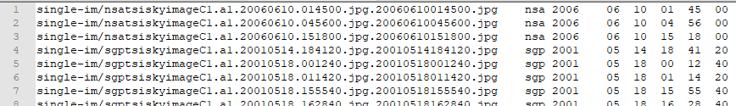

Figure 5. Sample lines in haloloop-processlist.txt. The items in this temporary file are: path/imagefile, origin, year, month, day, hour, minute, seconds (UTC). The origin identifier and time will be used to find the position of the sun as an image is processed.

## **Input Parameters**

Haloloop will read a parameter file to allow control over the image manipulations and the analysis settings. The program is looking for a file named

*Imagelist-haloloop-in-prms.txt*

The word Imagelist is replaced with the name you gave as a list when prompted. Haloloop checks for the existence of this file.

As of July 13, 2018, this file has the following content and layout:

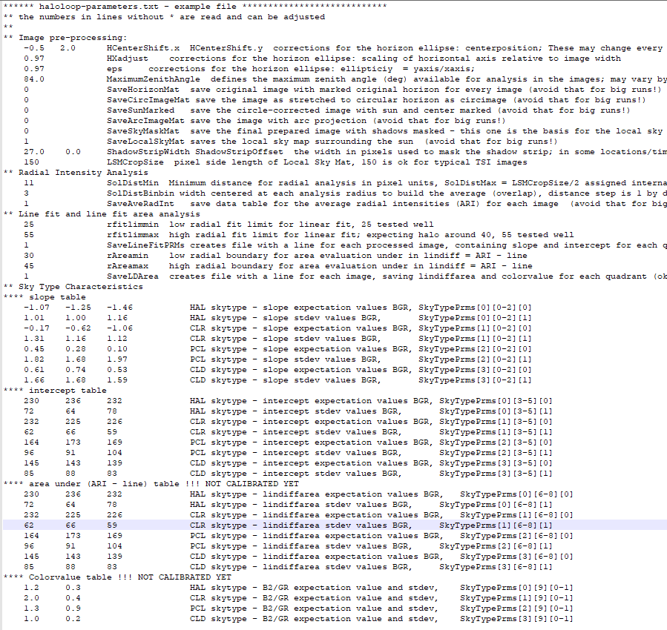

Figure 6. Screenshot of the parameter file. Extensive comments allowed behind the required parameters.

A functioning file can be found in the test folder. Haloloop will read all the lines, and also record them back into the runlog file. The runlog file itself is able to serve as a parameter file. The meaning of the various entries will become clear in the explanations in further sections in this document.

# **Image Preparations**

Every image in the process list undergoes the procedures described in this section.

## **Importing images**

Using the temporary processlist, each image file is opened and read as a Mat type under the variable name

*SourceImageMat*

Typically, such an image has dimensions 288 cols and 352 rows. A safeguard for an empty image is included.

Image coordinates:

True horizon (θ=90°)

Image horizon (θm)

HorizonCenter

HorizonRadius

Xpix (max: cols)

Ypix (rows)

Xalph

Yalph

|  |  |  |
| --- | --- | --- |
|  | Pixel position | Skydegree coordinate |
| Symbols |  |  |
| unit | 1 pixel = 1 pix | 1 sky degree = 1 sd |
| Origin | Upper left corner of image | |
| Maximum values |  |  |
| HorizonCenter | Point2f HorizonCenter | Point2f HorizonCentersd |
| HorizonRadius | Double HorizonRadius | Double HorizonRadiussd = θm  Implicitelt known already |
| SunCenter | Point2f SunCenter | Point2f SunCentersd |
| LSMCropSize | Is an input parameter in degrees, recommend 50 deg | |
| LSMCropSize | LSMCropSizesd |

## **Variables for the current image**

|  |  |  |
| --- | --- | --- |
| Mat Images |  |  |
| SourceImageMat | Originally imported current image |  |
| BWContrastMat | A black and white image used to find and mask the horizon in the image |  |
| cols | Number of columns of current image | int |
| rows | Number of rows in current image | int |
| HorizonCenter | Center coordinates of the ellipse in original image | Point2f |
| HorizonAxes | Semi axes of the horizon ellipse, as it refers to the original image | Point2f |

## **Identifying the horizon circle**

Previously, this was done by providing a mask file. I would like something more flexible, based on the current image. Even though the images are quite consistent I would prefer an image-based construction. This part should produce

HorizonRadius(x,y) (since it is an ellipse)

HorizonCenter(x,y)

Create a high-contrast image and find a fitting circle.

Left – the original TSI image. Right – the contrast mat, with initial guess horizon circle drawn. Apparently, an ellipse is needed instead of a circle. Also, fitting to the actual image is paramount since all further adjustments will be based on the correct placement of center and radius. The documentation for the original haloloop provides good resources for handling the ellipse.

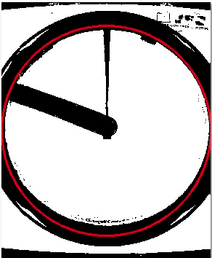

x

y

Figure 7. A BWContrastMat demonstrating the light-blue section for which the radial brightness is averaged. Yellowline sketches radial brightness behavior on which a radius decision is based.

I am using the average arc intensity along each axis direction to identify the transition from sky to horizon. A few exceptions are considered, including the avoidance of high ellipticity.

Parameters:

*HorizonEdgeBWLimit* should be set between 75 and 90 for the threshold color value. It is used to find the edge.

ensure that misidentified horizon ellipses do get caught. Examples for results:

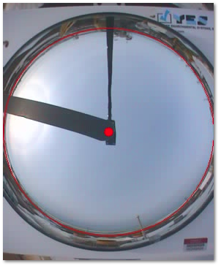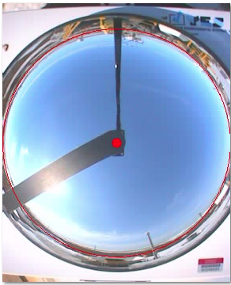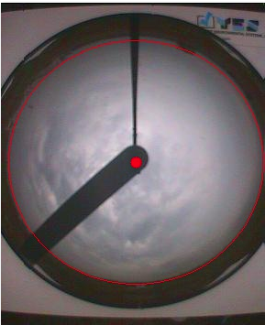

Figure 8. Sample images with horizon ellipse and center marked.

Tested on the single-image folder. There are still a few potential problems. I will keep revising the conditions for the ellipse axes as more images are examined.

Potential further corrections:

* Restrict the center to a tolerated area within the center of the image
* Restrict the ratio of HorizonEllipse.x and y to a tolerance value

x

0

A

B

x0

x1

a

b

Figure 9. Coordinates of relevance in identifying the horizon ellipse

a HorizonEdge[2] relative to x0

b HorizonEdge[0] relative to x0

X0 HorizonCenter.x (original)

X1 HorizonCenter.x (new)



The algorithm has some difficulty placing the vertical axis and center (rows).

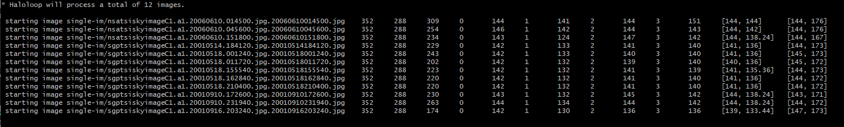

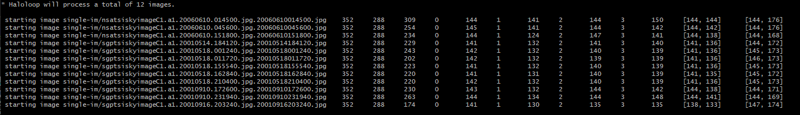

After I cleaned up the correct handling between double and integer types, in particular in coordinate transformations.

All Horizon-related characteristics are double.

## **Removing Distortions**

### ***Ellipse to circle, and masking:***

Basic task: Stretch the original elliptic image along the vertical axis to produce a circular image. An ellipse may be introduced if the camera was not perfectly positioned above the center of the mirror. These corrections are typicalle very small.

xC

xE

yE

yC

R

εR

θ

Figure 10. Stretching an elliptic horizon to a circular horizon.

Defining 

|  |  |
| --- | --- |
| **Elliptic view port** | **Circular view port** |
| F:\HaloLoop\Testruns\testpolyfit\Mask.jpg | F:\HaloLoop\Testruns\testpolyfit\Mask.jpg |
| with  pixel position in zenith image  position of view circle  radial vector from view center | with  pixel position in arc image  position of view circle  radial vector from view center |
| equation for ellipse | equation for circle |
| Connecting element: | |
|  |  |
| Transformation: | Transformation: |
| original | circimage |

* Work flow internally:

SourceImageMat -> CircImageMat

* Successfully implemented 6-18-18
* Has save option circimage

### ***Removing the mirror distortion?***



horizon

zenith

RH

RM

αH

αH

ϕH

ϕH

θH = 90o

hH

α

α

a

ϕ

θ

RM

RM

ϕ

h

L

Incident ray

from horizon

Incident ray

from zenith angle θ

Zenith angle θ

Mirror angle ϕ

Camera angle α

Mirror radius Rm

Camera distance from mirror surface L

Figure 11. Ray paths on TSI mirror.

The support program testangle.f95 in the doc folder generates solutions for these iterative equations, while allowing variations in the L/R ratio:

* Iterations for ϕ: 
* Iteration for α: 

The program testangle.f95 generates a csv file, allowing to explore the behavior:

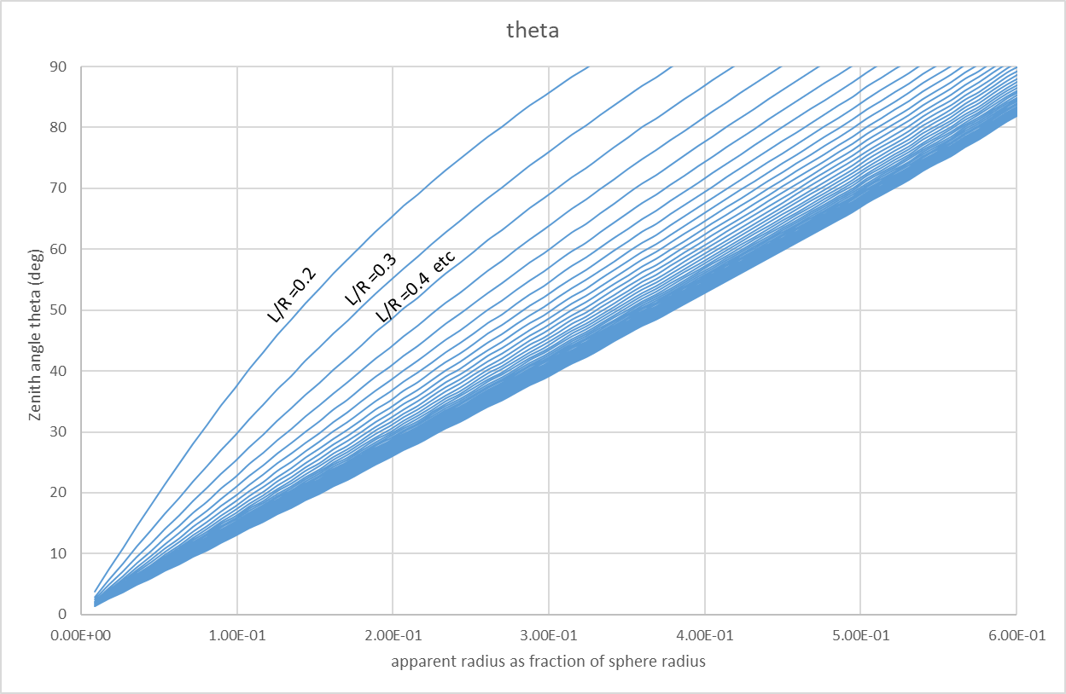

Figure 12. Zenith Angle versus apparent zenith distance in the image. This can be the key for the removal of the image distortion. Data can be found in testangle.xlsx

Currently implemented:



With r measured in the CircImageMat.

I am still struggling with this.

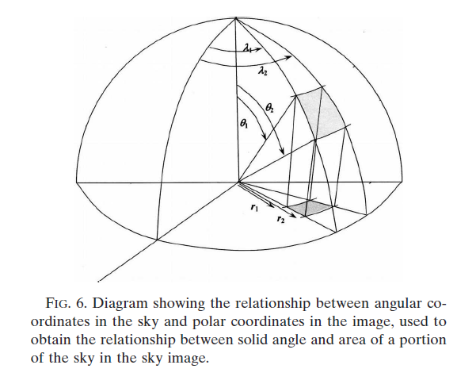

Figure 13. Struggling with image distortion. The radii r are what is measured in the image, θ are zenith angles, λ are azimuth angles. This figure is cropped from[1]



This should work. Try this. Works.

Next: do a thorough calibration of the horizon mask again.

## **Finding the solar position in image**

As opposed to the lens-based images and the older version of haloloop, we will use a geographical and time-stamp-based algorithm for the determination of the solar position.

Need the coordinates of the stations:

NSA NORTH SLOPE OF ALASKA 71° 19′ 22.8″ N, 156° 36′ 32.4″ W

ENA EASTERN NORTH ATLANTIC 39° 5′ 29.76″ N 28° 1′ 32.52″ W

SGP SOUTHERN GREAT PLAINS 36° 36′ 18″ N 97° 29′ 6″ W

OLI Olikiok Point, Alaska 70° 29’ 42’’ N 149° 53’ 9.6’’ W

### ***References:***

<http://www.stargazing.net/kepler/sun.html> (raw text document)

<https://en.wikipedia.org/wiki/Celestial_coordinate_system>

<https://en.wikipedia.org/wiki/Position_of_the_Sun>

<https://en.wikipedia.org/wiki/Horizontal_coordinate_system> *

|  |  |  |  |  |  |  |
| --- | --- | --- | --- | --- | --- | --- |
| Coordinate System | Center point | Fundamental plane | Poles | Coordinates | | Primary direction (0° Longitude) |
| Latitude | Longitude |
| Horizontal (alt-az, el-az) | observer | horizon | Zenith, nadir | Altitude (α)  Or elevation | Azimuth (A) | N or S |
| Equatorial | Center of the earth or sun | Celestial equator | Celestial poles | Declination δ | Right Ascension α or hour angle h | Vernal equinox |

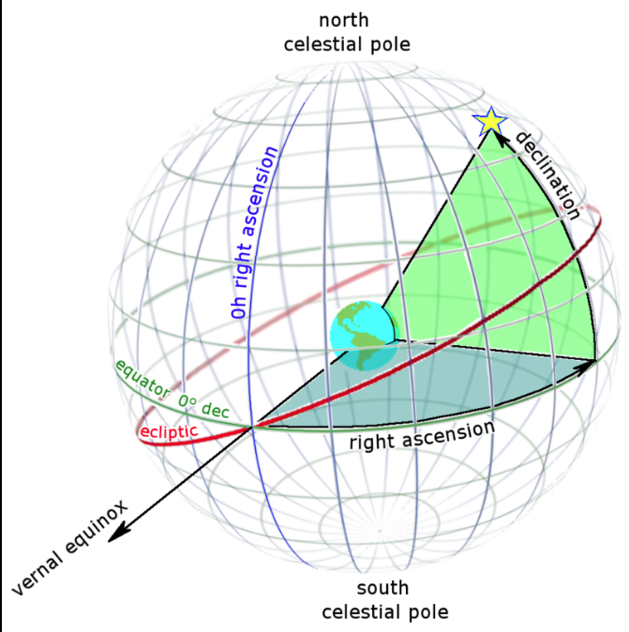

Figure 14. <https://en.wikipedia.org/wiki/Right_ascension#/media/File:Ra_and_dec_on_celestial_sphere.png>

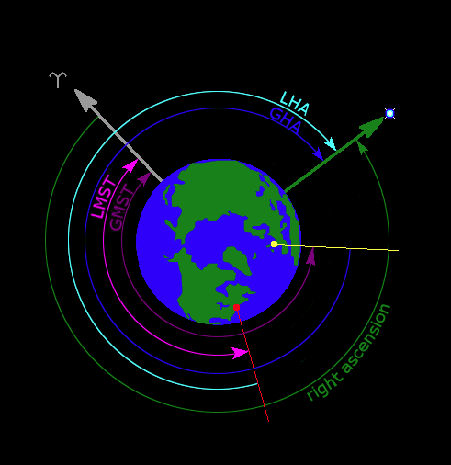

Figure 15. As seen from above the [Earth](https://en.wikipedia.org/wiki/Earth)'s [north pole](https://en.wikipedia.org/wiki/Geographic_pole), a star's local hour angle (LHA) for an observer near New York (red dot). Also depicted are the star's [right ascension](https://en.wikipedia.org/wiki/Right_ascension) and Greenwich hour angle (GHA), the [local mean sidereal time](https://en.wikipedia.org/wiki/Sidereal_time) (LMST) and [Greenwich mean sidereal time](https://en.wikipedia.org/wiki/Sidereal_time) (GMST). The symbol ʏ identifies the [vernal equinox](https://en.wikipedia.org/wiki/Equinox) direction. <https://en.wikipedia.org/wiki/Hour_angle#/media/File:Hour_angle_still1.png>

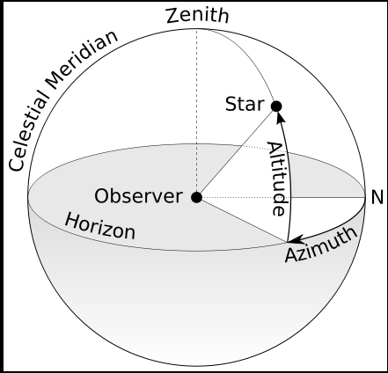

Figure 16 <https://en.wikipedia.org/wiki/Horizontal_coordinate_system#/media/File:Azimuth-Altitude_schematic.svg>

Strategy:

1. Use date and time to find the declination, right ascension, and hour angle of the sun
2. Use the local coordinates to find elevation and azimuth

Following the math on <https://en.wikipedia.org/wiki/Celestial_coordinate_system>

### ***Testing in spreadsheet***

Variables:

|  |  |  |
| --- | --- | --- |
| **name** | **symbol** | **Coordinate system and other remarks** |
| Right ascension | α | Celestial system  with reference at vernal equinox for 0 (somewhere in Gemini)  this one will change with position of earth along the ecliptic |
| Declination | δ | Celestial system; angle of deviation from the ecliptic. The sun moves between declination +/- obliquity, with passing zero at the equinoxes. |
| Observer latitude | φo |  |
| Observer longitude | λo |  |
| obliquity | ε | Max tilt angle; 23.4° should be close enough |
| Greenwich sidereal time | θG | This time is taken at 0:00:00 for a day. It does not change during the day. The hour angle will measure the daily rotational moment. |
| Hour angle | h | Observing the sun from earth, the solar hour angle is an expression of time, expressed in angular measurement, usually degrees, from solar noon. At solar noon the hour angle is 0.000 degree, with the time before solar noon expressed as negative degrees, and the local time after solar noon expressed as positive degrees. For example, at 10:30 AM local apparent time the hour angle is -22.5° (15° per hour times 1.5 hours before noon). |
| Azimuth | A | Horizon coordinate, measured from S (0 at S, positive to the W |
| Elevation | a | Angle above horizon  Zenith angle is complementary to 90° |

Tested this in time-coordinate-testing spreadsheet. If G is approximated with 6.6, the sidereal time will be within about 5 minutes of the actual sidereal time. That should be sufficient for the purpose. Refine if necessary

Checking out reference values. Some observations, helping understanding:

1. GMST is specific for a day. It does not shift with UT. It represents the sidereal time on the start of the day. One can understand and estimate it by considering the ecliptic a clock, which passes noon at the vernal equinox. GMST roughly assumes these values:
   1. Noon = vernal equinox
   2. Midnight = autumnal equinox
   3. Winter solstice = 6 am
   4. Summer solstice = 6 pm
2. The hour angle is the sum of GMST and Longitude and UT, and positions a sidereal angle. For example:

12:00

0:00

6:00

18:00

GST

17:12:50

long

-156.6

UT

1:45:00

LST

8:31

Hour angle

Figure 17. Relationship between GST, LST, LON, and hour angle.

* 1. With GMST 17:12:50
  2. And Lat -156.6 deg
  3. The hour angle (local sidereal time) is calculated as



Now add the UT, say 1:45:00:



This last angle corresponds to the local sidereal time of 8.53h or 8:31:24 h (close. There are small corrections in the seconds of precession and leap years are considered)

This example is for the first test image in single-im at NSA.

<https://www.esrl.noaa.gov/gmd/grad/solcalc/azel.html> Az/El reference

<http://www.csgnetwork.com/siderealjuliantimecalc.html> GST/LST reference

<https://eclipse.gsfc.nasa.gov/TYPE/sun2.html#su2006> Right Ascension/declination reference

### ***Procedure for for solar position as used in haloloop:***

Input parameters:

year

month

day

hour

minute

second

Latitude

Longitude

Other parameters:

Length of year 

Vernal equinox as reference  (March 20, 5 pm, 2019)

Obliquity 

Procedure:

1. **Converting UTC to Greenwich sidereal time (GST)**: using the position on the ecliptic, with 0 at noon of vernal equinox



Time in day of year *t* using timeinfo, as referenced at

<https://stackoverflow.com/questions/19110675/calculating-day-of-year-from-date>

is the YearDay

Keep this within 0 and 360°.

1. **Local Sideric Time (LST)**



All in same unit, of course. I will use degrees. Longitude negative if W. UTC between 0 and 360°. Project the LST back into interval between 0 and 360°.

1. **Ephemerides of the sun on that day**

**Declination:**  

**Right Ascension:** 

within 5 minutes. Project back into 24h format.

<http://astropixels.com/ephemeris/sun/sun2018.html>

<https://eclipse.gsfc.nasa.gov/TYPE/TYPE.html>

1. **Hour angle:**



1. **Horizon Coordinates**

I am following <https://en.wikipedia.org/wiki/Celestial_coordinate_system> , section (Equatorial to horizontal). There is more discussion than what I will include here, in particular concerning the signs and intervals of allowed angles.

Azimuth 

Elevation  (a between 0° and 90°)

Implemented the version of atan2(y,x), as proposed in reference.

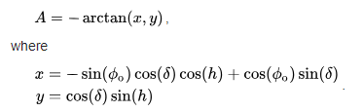

The C++ version of the two-argument inverse tangent returns angles between -180 and 180°:



For an unknown reason, a 180-degree correction is not necessary in order to produce azimuth angles wrt N.

The following lines compute the azimuth angle in haloloop, 6-26-18ff: 

Checks out all 12 single-test images correctly.

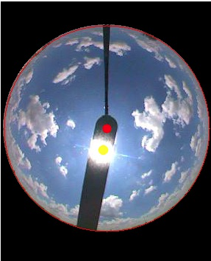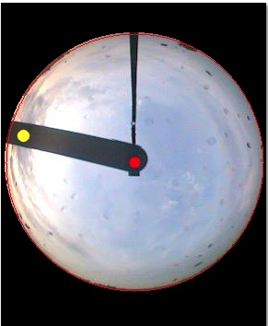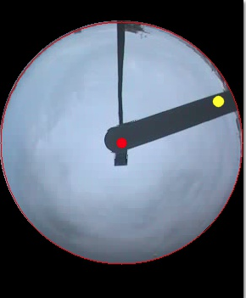

Figure 18. Examples of images with the solar position marked, using time, geographical position, and date. Base image is the CircImageMat.

## **Masking the shadow strip and the camera mount**

This final image preparation procedure will result in

*SkyMaskMat*

Which is the image to be forward to the radial analysis procedure. Opencv drawing functions are used to mask the area in black. The camera mount is a polygon defined by



Figure 19. Section of the code that covers the camera mount with a black polygon.

For the shadow strip, we use the solar position to orient a rectangle and a circle. Here is the geometry:

RadialVector

A

B

C

D

width

TangentialVector

Figure 20. Coordinates of shadow strip points.



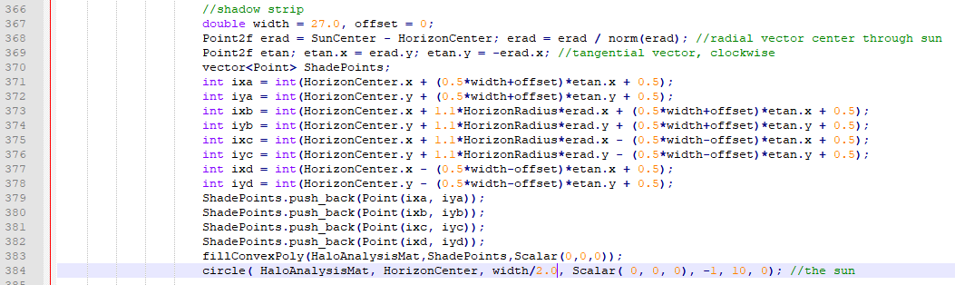

Figure 21. The part of the code that places a rectangle and a circle over the outline of the shadow strip.

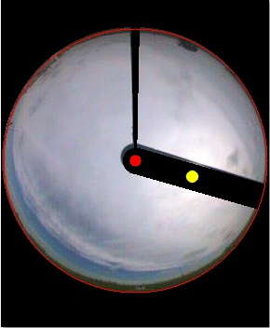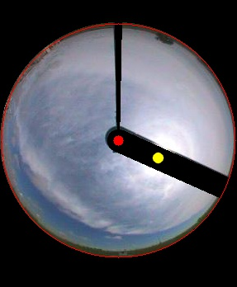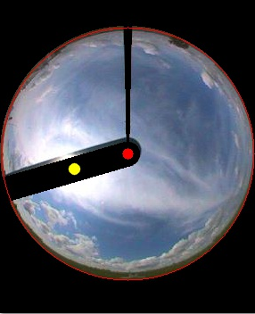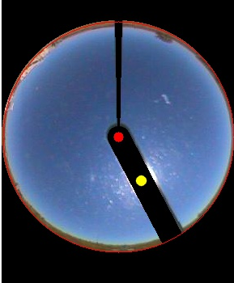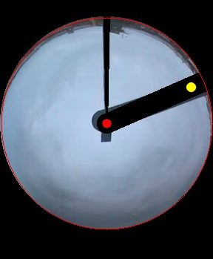

Figure 22. Some examples of SkyMaskMat. There are imperfections, mostly related to placement of horizoncenter.

## **Local Sky Mat**

The LocalSkyMat is a rotated and cropped version of SkyMaskedMat. It is produced in two steps:

1. Rotate SkyMaskMat such that the sun and shadow strip are aligned with the bottom center direction of the image.
2. Crop such that sun sits in center to a size CropSize =150.

**Procedure:**

sun

Relative

elevation β

Relative

Azimuth α

SkyMaskedMat (SMM)

HAIpos vector

SkyRotMat (SRM)

sun

Relative

elevation β

Relative

Azimuth α

HAIpos vector

1. Create the Mat for SRM.
2. Go through all points on SRM and identify the corresponding pixel in SMM. It is a rotation.

 with γ = A - 180°

1. Assign the pixel color from SMM location to the SRM location. Rotate the sun position as well.
2. Then cut out a rectangle around the sun for analysis to create *LocalSkyMat*, square size *CropSize*.

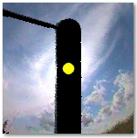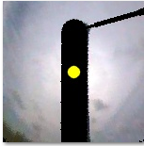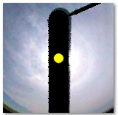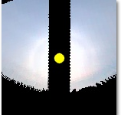

Figure 23. Result examples for the LocalSkyMat operations.

Additional 10-242018: azimuth scaling (a rough band aid)

I had to introduce a zenith stretch factor. If just a rectangular crop is performed, the horizontal units are of different meaning at high and low zenith angles.

As time is becoming a pressing issue, I decided to include an ad-hoc transformation (instead of working out the complete coordinate transformation), that stretches images relative to the 22-degree mark at θ=45°. This targets in particular the azimuth stretch for solar positions below θmax/2.

So

S

θ

φ



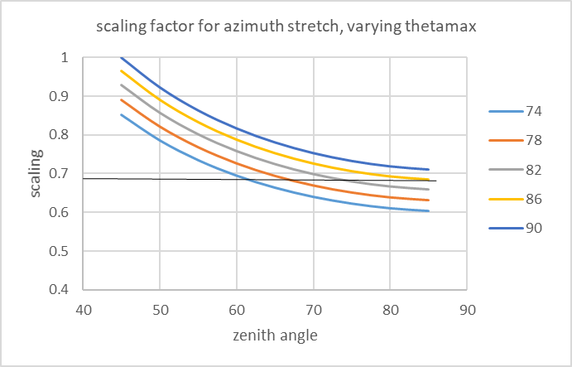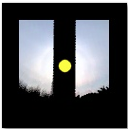

The scaling is implemented in the LSM section

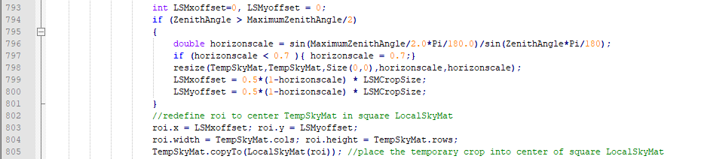

A cutoff of 0.7 is applied, and no scaling is applied for low zenith angles. This may become a problem for summer months? The master file has been retrained on October 24 2018 to accommodate this, and extensively tested in sgp201803.

## **Camera aging and color corrections**

For parts of the image series, the camera sensors have aged to produce darkened and tinted images. Since color channel properties are used to identify skytypes and halo scores, I need a mechanism to fix this. One first idea could be this:

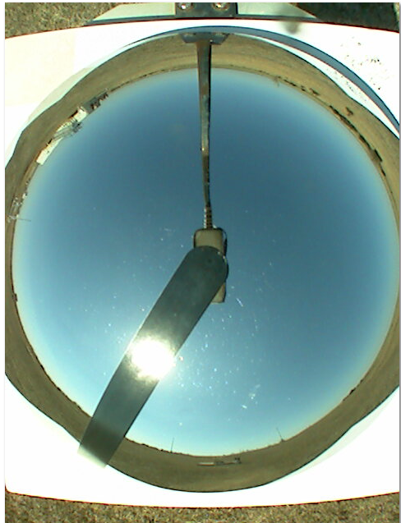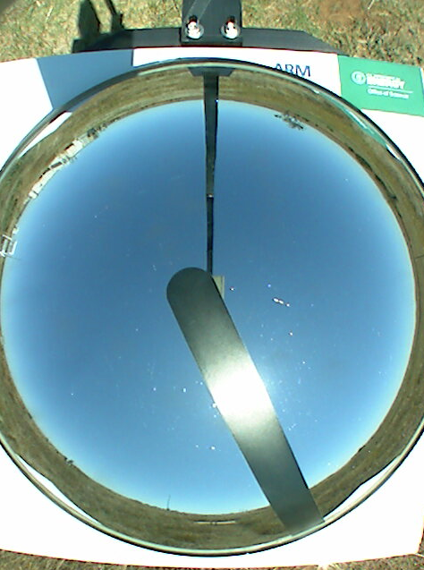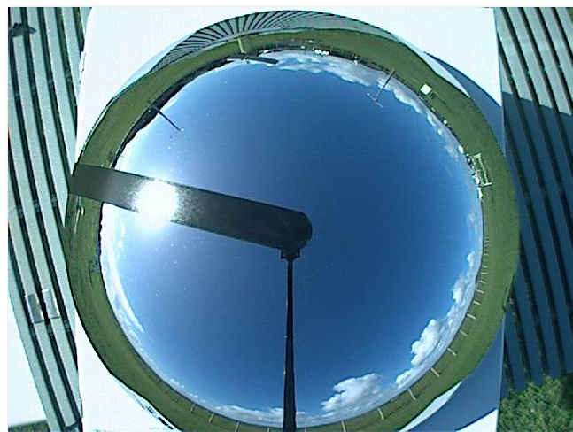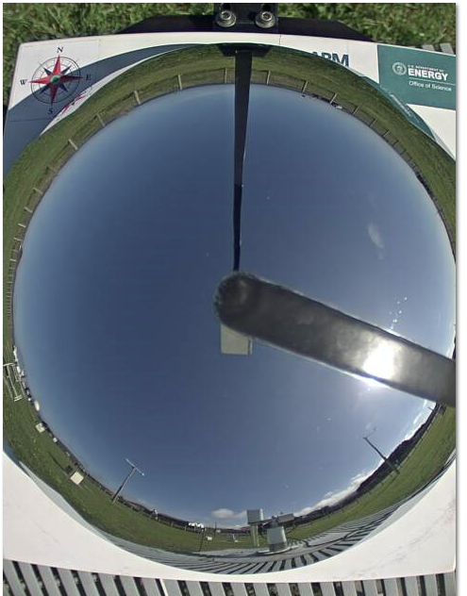

Figure 24. Color samples for clear-sky days, left to right: SGP 04-2018, SGP-05-2011, ENA 2016, ENA 2018

The problem is demonstrated in Figure 24. Absolute colorvalues, as well as relative color values are used in skytype assignments and halo evaluations. However, even the same camera shifts in hue as it ages, and there are differences between cameras. This will impede my strategy for sky recognition

I propose to implement a “color normalization” of each batch of images. It is reasonable to expect that the color drift is a slow process, and the calibration only needs to be undertaken every few months. As a practical matter, I will follow the steps suggest in <https://stackoverflow.com/questions/6615002/given-an-rgb-value-how-do-i-create-a-tint-or-shade> , in particular

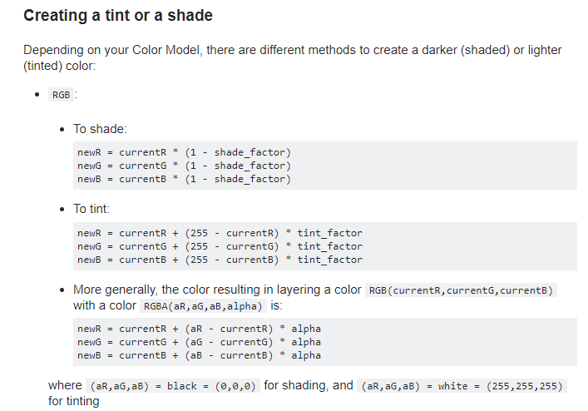

Strategy: do this to the sky mat and see.

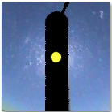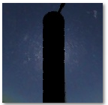 shading with shade factor 0.5

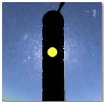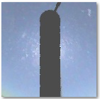 tinting with tint factor 0.3

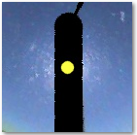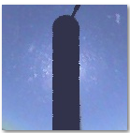color layering [250,170, 160,0.3] this might work?

**Implementation:**

1. Do the color adjustment before any other image modification! That way, all blacked out areas remain black!
2. The operation preserves total brightness, while assuming linear color behavior. The target color is defined in the input as a difference. Find a meaningful value for that by following these steps:
   * 1. Select a clear-sky image in the series with clear right upper quadrant.
     2. Use the ColorPic application in Windows (or other) to sample BGR values in the right upper quadrant. Decide on a good average for BGR, as represented by the sample image.
     3. I have decided, that a good standard clear sky will have B0G0R0 values of (180, 120, 85) referring to image CLR/sgptsiskyimageC1.a1.20010910.231940.jpg.
     4. The respective color corrections for the input prm file will then be floating point numbers from ratio operations:

 

1. The adjustment strength α is arbitrary. For camera series with little colordrift, the number should be chosen closer to zero (0 ...0.3). For strongly discolored images, a stronger factor is necessary (0.5 .. 0.9). It does make sense to scale these factors such that the one for blue is equal to 1. That allows to see if coloration across a series is consistent, even with varying brightness. Since all scaling is done internally in haloloop, based on local brightness, only ratios for these factor count.
2. Start with color shift
3. Then apply a shade scaled by old over new total intensity
4. Then adjust and scale.

***Let me take you through the steps to create meaningful color parameters:***

1. *In parametertesting, there is a small spreadsheet for the computations*
2. *In CLR-list1, the image is nsatsiskyimageC1.a1.20150509.001830.jpg.20150509001830.jpg. Open the image in an image viewer. Open ColorPic. Hover over the right upper sky quadrant and measure the values for BGR.*

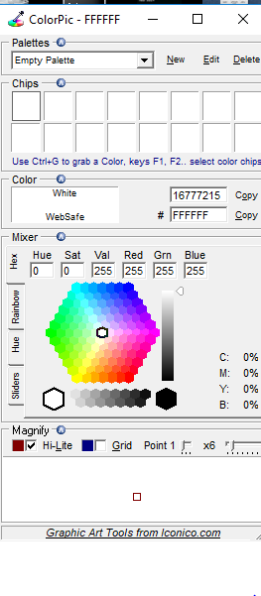

1. *Compute the ratios to a standard sky, using a spreadsheet.*

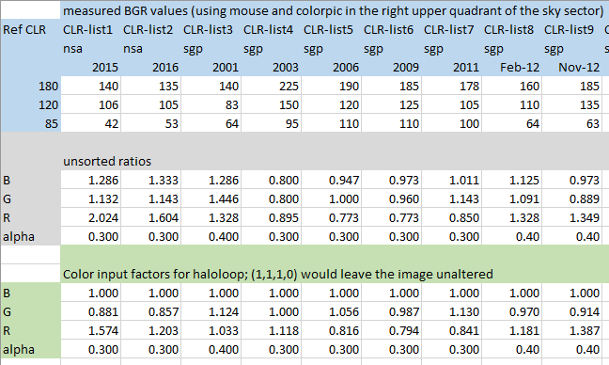

1. *Use these ratios in the input prm file, in the first line of image pre-processing:*
2. *Run haloloop, but export at least one of the intermediary image processing steps.*

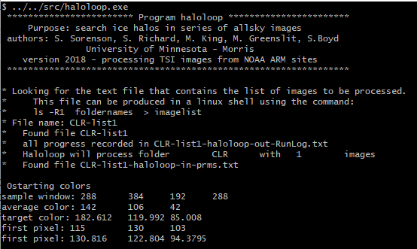

*(the output produced in this example will probably go away soon, was debugging)*

1. *Check the outcome:*

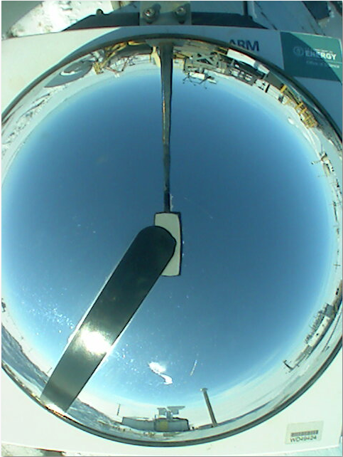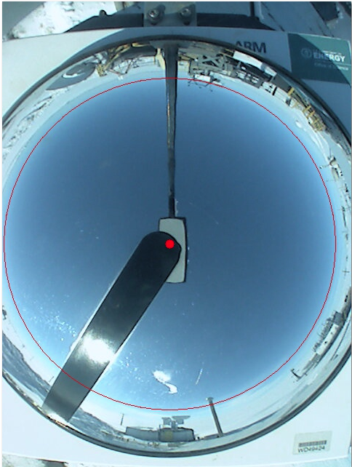

*Original and color-corrected image (with horizon circle). The measurements for the upper right quadrant changed from (140, 106, 42) to (130, 98, 50).*

1. *Now use this color line in in-prms for all images of that month/year. Perhaps compare beginning and end of the period to asses further color drift of the sensor through the period. But really, this color adjustment should not have to be done as often as the orientation adjustments.*
2. I must update all my parameter base in that case.
   1. Updated RAtesting/haloloop-out-propertylog-sorting.xlsx 9-24-2018
   2. Realizing that haloscore 1, using all 40 parameters now gives a 100% halo ID rate!
   3. Need to refine my haloscore procedure to include all 40 parameters. However, all 40 parameters together create a matrix of determinant 0, since several of the parameters are linear combinations of other parameters. Hence I use 31.

# **Halo Analysis**

## **Reference Images**

No single criterion can reliably identify the halo. However, each criterion can be assigned a probability factor which assesses whether the current criterion lies within a halo boundary zone. The probability factors will evaluate the halo criteria and sort them for four different cases as represented in the LocalSkyMat:

SkyTypes

HAL -CS cirrostratus

Sky is milky with variations, but now sharp cloud outlines; Sun position is clearly visible; a halo may be present in the image (sun and cirrostratus)

CLR Clear blue, cloud-free sky; sun position is clearly visible; no sharp cloud outlines within the analysis area of the LSM

PCL Partly Cloudy a variable sky with distinct low clouds and blue sky; analysis area contains sharp cloud outlines; often great variation between the sky quadrants of the LSM; solar position may or may not be clearly visible in the image

CLD Cloudy sky is covered, low light; sun is completely obscured.

I created a test folder with subfolders for each sky type. Each of these contains 20 images of each type, taken from various times and places to sample these parameters sufficiently.

The 80 test images can be found in: *test/parameter-testing*

It is critical that for all analyses the solar position and the horizon circle are correctly identified. For each subfolder, I lined up the lists of files, together with the parameter files containing the image calibrations.

## **Average Radial Intensity: ARI and ARIVar**

The average radial intensity outward from the sun is evaluated by averaging the BGR values over circular sections centered at SolDist, with a width of SolDistBin. The radial steps outward are taken in increments of 1 pixel.

SolDist

SolDistMax

SolDistMin

SolDistIncr=1

SolDistBin

4 - TL

3 - BL

2 - BR

1 - TR

Figure 25. Variables governing the radial intensity analysis. Sequential radial distance bins do overlap. Brightness is average over circular bins, separately for BGR.





Figure 26. Current definitions of these variables in the code. The radial mask properties are assigned in the introductory portion, while the ARI vectors are initiated when needed.

Procedure to compute ARI vectors **for each quadrant separately:**

1. Go through every pixel in LocalSkyMat.
2. Find its column and row coordinates.
3. Compute the distance to the sun of this pixel.
4. Assign its BGR values to the average vectors for Average Radial Intensity (ARI) by identifying all bins into which this pixel falls.
5. Collect the stdev for each radial distance



1. Also count the number of pixels added in each bin.
2. Compute the average for ARI , resolved by sky quadrant and color channel (ARIVar)

## **Using Running Averages to analyze the ARI for Halo Indicators: EtaDerivMarkers**

This is a process I started to implement on September 5, 2018. It replaces the original efforts to subtract a fitting line. The halo behavior shows in a plot of



In which is the deviation of the ARI  from the running average intensity, taken as average of radial intensities with a width of 6 skydregrees. This width then is transformed into a number of bins, depending on the resolution of the image. If a halo is present



Therefore will exhibit a maximum in halo images, at particular radial distances from the sun. The maximum could be ascertained directly from , together with the adjacent positions where  changes sign. However, sky situations can be widely varied, and a number of images do exhibit a maximum for , but do not actually change signs in the appropriate positions. Hence, the maximum will be analyzed using a numerical derivative of .

The derivative is approximated as



The properties of  and its derivative in a halo image appear to have a few characteristic features, observable in Figure 27. Three examples of and its derivative for halo images. and Table 2:



1. A swing from low to high values for  for an interval between 17 and 22 sd. Often, this is a swing from negative to positive, but not always. Depending on other picture and sky conditions, this swing upward may occur from low positive values toward higher positive values.
2. A steep rise in brightness, followed by a maximum shortly after. The derivative describes this behavior best and most consistently, based on the three-image sample.
3. The derivative shows a positive maximum at **18.7 sd, stdev 0.8**
4. The maximum in slope is followed by a zero point (PMcrossing) at **1.0 sd after the max slope, stdev 0.4 sd.**
5. For a single quadrant, the location of the max dn/dr and the subsequent passage through zero are highly correlated in each color channel. The stdev of max slope loc between the color channels is less than 0.65. In fact, it appears that it is smaller than the inherent angle resolution limited by the pixel resolution of the image.

Table 2. Running Average Analysis for **three halo images**. Both,  and are analyzed for markers of halo presence. The angular resolution of the image is given in column 1, depending on image size and maximum zenith angle. Data are contained in I:\haloloop\test\parameter-testing\RAtesting in Summary.xlsx

|  |  |  |  |  |  |  |  |  |  |  |  |  |  |  |  |  |
| --- | --- | --- | --- | --- | --- | --- | --- | --- | --- | --- | --- | --- | --- | --- | --- | --- |
| image | quadrant | channel | Mpcross | Pmcross | Maxloc | Minloc | Maxloc | MPcorss | PMcorss | **Mptomax** | **mxto0** | **PMtoMP** | **0-0** | stdev(BGR) for maxdn/dr loc | | |
| sgptsiskyimageC1.a1.20180310.194300.jpg  min dr  0.33 sd | TR | B | 18.36 | 22.99 | 18.85 | 17.53 | 18.19 | 17.70 | 19.02 | **0.50** | **0.83** | **4.63** | **1.32** | 0.0 | 0.2 | 0.2 |
| G | 18.03 | 21.00 | 18.85 | 17.20 | 18.19 | 17.36 | 18.69 | **0.83** | **0.50** | **2.98** | **1.32** |
| R | 18.03 | 20.67 | 18.85 | 17.53 | 18.19 | 17.70 | 18.69 | **0.83** | **0.50** | **2.65** | **0.99** |
| BR | B | 18.03 | 22.33 | 19.18 | 17.20 | 18.19 | 17.03 | 19.02 | **1.16** | **0.83** | **4.30** | **1.98** | 0.2 | 0.0 | 0.2 |
| G | 18.03 | 20.34 | 19.18 | 17.20 | 17.86 | 17.03 | 19.35 | **1.16** | **1.49** | **2.32** | **2.32** |
| R | 18.03 | 20.01 | 19.18 | 17.20 | 18.19 | 17.03 | 19.02 | **1.16** | **0.83** | **1.98** | **1.98** |
| enatsiskyimageC1.a1.20150420.142030.jpg  min dr  0.35 sd | TR | B | 17.10 | 19.92 | 19.04 | 15.51 | 18.33 | 15.33 | 18.86 | **1.94** | **0.53** | **2.82** | **3.53** | 0.4 | 0.2 | 0.2 |
| G | 17.10 | 19.92 | 19.04 | 15.16 | 18.33 | 15.33 | 18.86 | **1.94** | **0.53** | **2.82** | **3.53** |
| R | 17.10 | 19.56 | 18.33 | 15.86 | 17.63 | 15.69 | 18.51 | **1.23** | **0.88** | **2.47** | **2.82** |
| BR | B | 18.51 | 21.33 | 19.39 | 15.86 | 18.68 | 15.69 | 19.56 | **0.88** | **0.88** | **2.82** | **3.88** | 0.0 | 0.0 | 0.0 |
| G | 18.51 | 21.33 | 19.39 | 15.86 | 18.68 | 15.69 | 19.56 | **0.88** | **0.88** | **2.82** | **3.88** |
| R | 18.15 | 20.97 | 19.39 | 15.86 | 18.68 | 15.69 | 19.56 | **1.23** | **0.88** | **2.82** | **3.88** |
| /nsatsiskyimageC1.a1.20060610.045600.jpg  min dr  0.60 sd | TR | B | 19.58 | 23.19 | 21.68 | 18.67 | 19.88 | 18.97 | 21.38 | **2.11** | **1.51** | **3.61** | **2.41** | 0.6 | 0.3 | 0.3 |
| G | 20.18 | 26.80 | 21.68 | 18.07 | 20.48 | 18.37 | 21.38 | **1.51** | **0.90** | **6.63** | **3.01** |
| R | 19.58 | 26.20 | 21.08 | 18.07 | 19.27 | 18.37 | 20.78 | **1.51** | **1.51** | **6.63** | **2.41** |
| BR | B | 19.58 | 25.60 | 21.08 | 18.07 | 19.88 | 17.77 | 21.38 | **1.51** | **1.51** | **6.02** | **3.61** | 0.6 | 0.3 | 0.6 |
| G | 18.97 | 23.19 | 20.48 | 17.47 | 18.67 | 17.17 | 20.18 | **1.51** | **1.51** | **4.22** | **3.01** |
| R | 18.97 | 23.79 | 20.48 | 16.87 | 19.27 | 17.17 | 20.78 | **1.51** | **1.51** | **4.82** | **3.61** |
| ave |  |  | **18.43** | **22.17** | **19.73** | **16.96** | **18.70** | **16.95** | **19.70** | **1.30** | **1.00** | **3.74** | **2.75** |  |  |  |
| stdev |  |  | **0.90** | **2.25** | **1.05** | **1.03** | **0.77** | **1.13** | **1.01** | **0.43** | **0.39** | **1.48** | **0.95** |  |  |  |

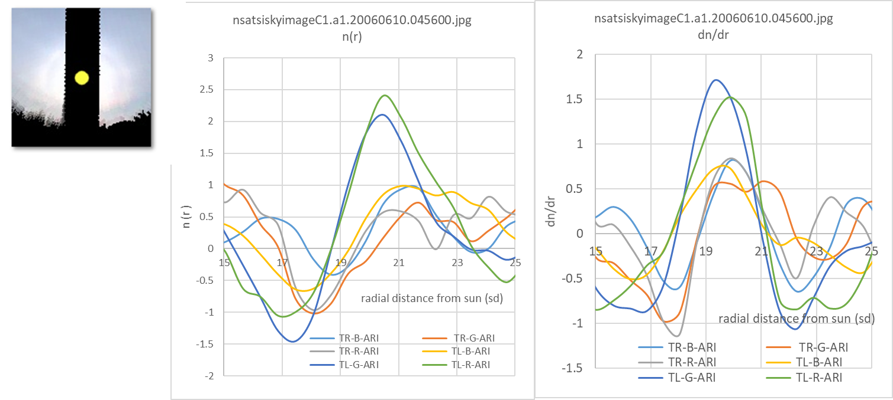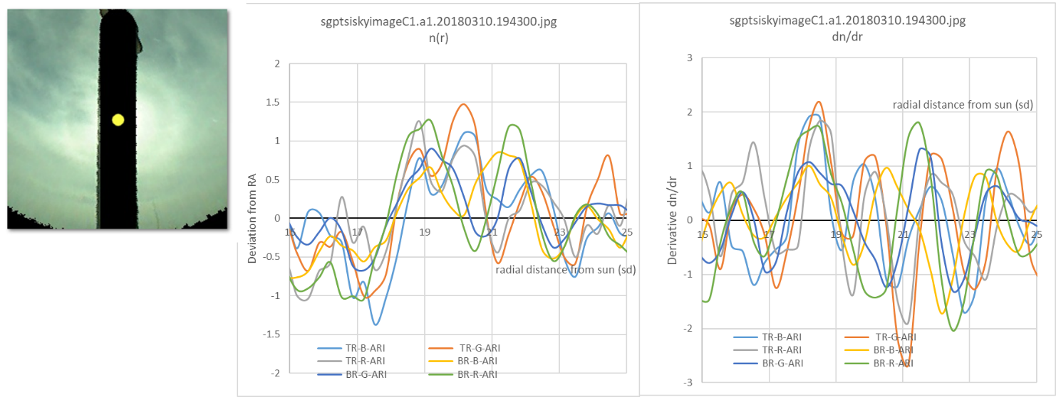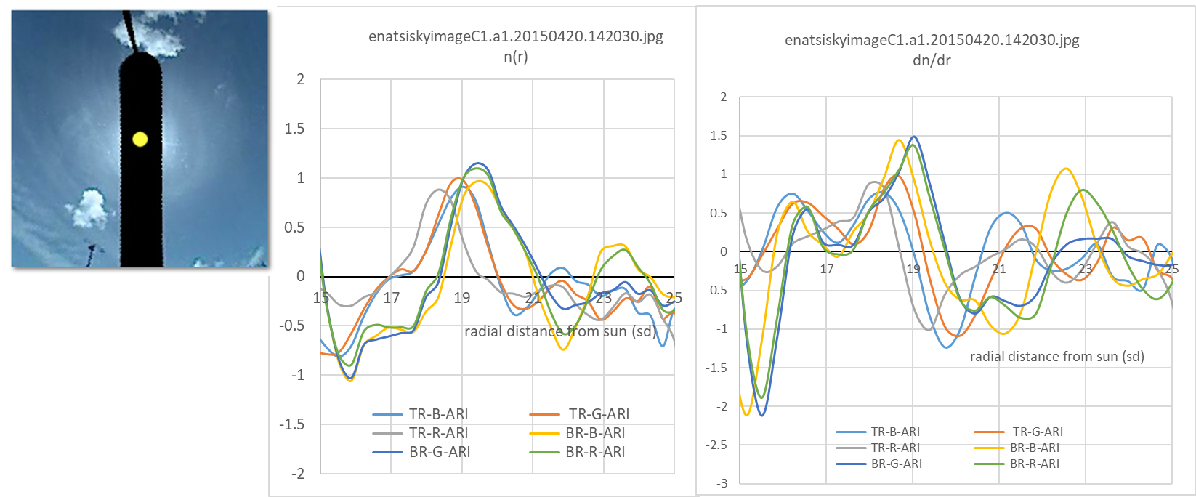

Figure 27. Three examples of and its derivative for halo images. These data files are located in I:\haloloop\test\parameter-testing\RAtesting.

Algorithm outline:

1. Define limits of analysis interval. Current suggestion: (17 sd, 22 sd). RALowLim, RAHighLim
2. Evaluate and store the values for .
3. Find the radial location of the maximum for the derivative, LocMaxDer.
4. Find the radial location of the subsequent PM crossing for the derivative, LocPMDer.
5. Find the radial location of the subsequent minimum, LocMinDer.
6. Store these markers in a field EtaDerivMarkers[icolor][iquad][0-2]
7. Also, count the number of minima and maxima of the derivative within the analysis interval. In a good halo image there should be less than three. Store in EtaDerivMarkers[icolor][iquad][3]
8. Find the stdev (BGR) for all three locations. Store these variances in EtaDerivMarkers[icolor][iquad][4-6]
9. Evaluate these for the sets of sample images for parameter testing and refine expectation values and stdevs for these values.

## **Line fit to ARI: slope and intercept**

The density of scattering particles in the atmosphere influence the decay of brightness with radial distance from the sun. For a very cloudy sky, for example, the solar position may not appear as one of contrastful brightness, which means that is not exhibiting a pronounced decline, possibly even a positive slope, but generally low values of brightness. On a clear day, with few scatterers, the radial brightness may decline sharply at first, and then slower. A cirrostratus layer, such as on a halo day, leads to a particular rate of decrease of brightness around the sun. These characteristics are best extracted using a line fit to  within the analysis interval. The slope and intercept information will be used to determine the skytype.

The linear fit to  will be undertaken between these limits:

* Lower boundary: *rfitlimmin* = 15
* Upper boundary: *rfitlimmax* = 26

Performing a least-square fit of  within the limits above, and saving slope and intercept for each quadrant.

Reference for least-square fitting algorithm: <http://mathworld.wolfram.com/LeastSquaresFitting.html>

For a set of points , the least-square fit line can be found as

Slope:  with 

and 

Intercept: 

R2:  with 

If the option *SaveLineFitPrms* is set to 1, the a continuous file will be written with one line per image, listing the line fit parameters for each color and quadrant.

Internally, the line fit parameters are stored in a field named linefitprms.

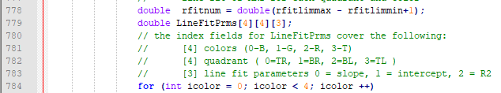

Figure 28. Screenshot of the definition of LineFitprms, showing the index assignments.

## **Relative Blue Ratio: ColorValue**

It had been found previously that the portion of intensity in B can be used as a supporting indicator. I will also keep track of the average for the blue ratio during the computation for each quadrant:





Figure 29. Screenshot of ColorValue definition, showing the index assignments.

A clear sky has a large blue fraction. The value of this variable generally sits around 2 for clear skies. For a cloudy sky, the color value tends around or just below 1.

Difficult cases include overexposed portions of an image, in which case all color channels have been saturated to 255. IN such image regions, a color value can not be reliably assigned. This would sometimes be the case close to the sun.

Observing the behavior of the small sample of images, the following image parameters will undergo further examination:

1. Line fit: slope and intercept
2. Color value
3. Stdev in of ARI in each color channel

## **Defining the Parameter Space: Skytype criteria and halo criteria**

I:\haloloop\test\parameter-testing\RAtesting

The image parameters were computed for all the possible criteria of importance, as identified above. I used the 20 images of HAL, CLR, PCL, and CLD types each in order to create computed averages, standard deviations, and extreme values for a diverse set of images. The sample images were taken from all locations and across the years. Since they are not arranged by time series, the image adjustment settings had to be separated into series of input files, example name HAL-list1-haloloop-in-prms.txt. These contain the appropriate horizon and solar position adjustments for the images in HAL-list1. Since these may vary quite considerably due to camera changes, position adjustments etc, there are about 10 input lists for each of the skytype.

The following values were computed and compiled for four quadrants (if sun above zenith angle 68°) and all images. This list defines the **SkyType** of a LocalSkyMat:

1. Line fit: **slope** of the average radial intensity (ARI) in units of BGR value per sky degree (BGR/sd)

The slope varies with the presence of scatterers in the atmosphere. A cloudy sky produces a zero or positive change in brightness radially out from the sun. A clear blue sky has a smaller decline of intensity outside of 13 sky degrees than a cirrostratus sky. There are also useful differences in the behavior of the three color channels.

1. Line fit: **intercept** of the ARI in units of BGR value

The intercept of the line fit can be seen as a placement of the general image brightness, and is clearly lower for cloudy days compared to days with clear or partially clear skies.

1. **Variation in average radial brightness** for the line fit interval (**ARIvar**) in units of BGR value

In order to separate partially cloudy skies, the general variations in the average radial brightness have been computed as the standard deviation of ARI. Large ARIvar correlates with the presence of low, sharply outlined clouds.

1. **Color Value B2/GR** within the line fit scope

A high color value would mean a dominance of blue components, while a value close to 1 corresponds to gray skies. This particular criterion separates out the clear skies very well.

In addition, the following criteria were used to identify a **halo score f**or an image:

1. Slope
2. Intercept
3. ARIvar
4. CV
5. EtaDeriv: LocMaxDer, LocMinDer, ….

Still working on this.

## **Multivariate Normal Distributions to assign Sky Type Scores and Halo Scores**

Let’s discuss this in terms of skytypescore. This score uses three variables for each color channel plus the ColorValue, in each solar quadrant.

That means, each quadrant is assigned 10 variables: 3 slopes, 3 intercepts, 3 ARIvar values, CV: 

For each skytype, I have computed the average values and standard deviations over the 80-image sample for the skytype: .

The vector  defines a point in parameter space that belongs to a particular skytype. I could now compute the distance of the image vector  from the point M, and thus establish a measure of how close the image sits to a particular average skytype. However, the elements of X are of different units and scales. In addition, I am really only interested in the probability that a particular image can be assigned to a particular skytype. This is where multivariate probability can help.

I am using this reference: <https://en.wikipedia.org/wiki/Multivariate_normal_distribution>

This involves the covariant matrix



This would be a 10x10 matrix for the skytype score. The elements of this matrix are variances and covariances



Hopefully, this matrix is positive-definite.

The, the value of the distribution density at point X is given as .

This means we will need the determinant and the inverse matrix of the covariance matrix. The good news is that this needs to be done only once after the sample expectation values have been established.

Perhaps of interest:

 is known as the Mahalanobis distance.

So, let’s take a stab at that inverse matrix: can be done in Excel, using command MINVERSE!

I am doing the work in this file  in folder I:\haloloop\test\parameter-testing\RAtesting

MMULT multiplies two matrices

MINVERSE inverses a matrix

## **Test Results for Skytype Scores**

, 

I tested, in the spreadsheet given above, the set of test images for



The norm factor is being replaced with a generic constant to accommodate reasonable numbers.

* The images had been sorted visually into sky types HAL-CS, PCL, CLD, and CLR.
* The relevant image properties had been computed and extracted from the propertylog file generated by haloloop, stored in the raw tabs.



* This output was further sorted into HAL, CS, PCL, CLD, and CLR tabs, cleaned up for bad data (no slope, low horizon, etc),



* For the SkyTypeScore, I selected the following 10 properties as relevant:
  + *B-Slope*
  + *B-intercept*
  + *B-ARIvar*
  + *CV*
  + *G-Slope*
  + *G-intercept*
  + *G-ARIvar*
  + *R-Slope*
  + *R-intercept*
  + *R-ARIvar*
* The vector and covariance matrix  and its inverse  was computed for each skytype, located in tab



* For all images, of every skytype, a score was assigned for each image. First, the Mahalanobis distance from  was computed for each image, and then a score assigned according to a multivariate normal distribution. The details of these computations for each skytype can be found in the tabs



* I summarized the skytype scores in tab .

While not completely perfect, this procedure is able to assign a correct skytype for almost all images, as the maximum of the four scores. **Error! Reference source not found.** **Error! Reference source not found.** shows the raw skytype scores for each test image. The raw numbers are not helpful, since with varying image quality, the scores can be quite different for similar-looking images. If the relative Skytype Score is considered, as in Figure 30, the skytype of an image is correctly identified in almost all cases! The relative SkyType Score is defined as



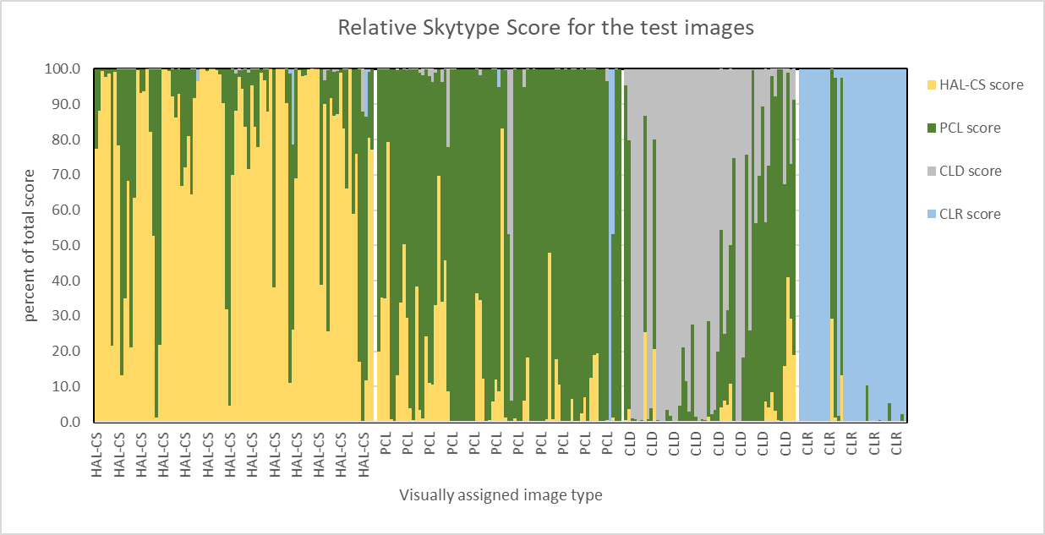

Figure 30. Relative contribution of a skytype to the total skytype score. This has promise.

So, what is needed to make the skytype assignment go in haloloop?

1. Compute the skytype score for each quadrant and for each skytype
   1. Configure a reproducible way to take them from a spreadsheet into an import file. Perhaps, a separate input file with only M and Sigma information?

*9-18-2018 done. Spreadsheet contained in src. Further description in section 4.10.*

* 1. Import the four inverted covariance matrices.

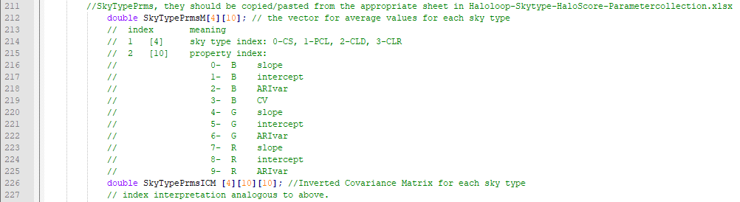

*9-18-2018 done. Can copy/past directly into the haloloop-in-prms file, and import into shown matrices into haloloop process.*

* 1. Compute 10 properties needed in the skytype score. Perhaps store them in a dedicated array, ordered in accordance with the imported matrices.

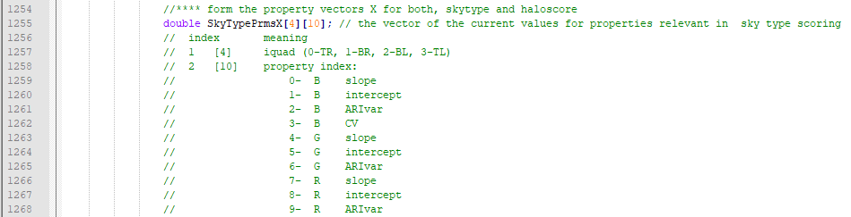

*9-18-2018 done. Also modified the property log file to accommodate the previously derived properties mxtozero etc. Ready to roll.*

* 1. Compute the Mahalanobis distance for each skytype (matrix multiplications!).
  2. Compute each raw skytype score.

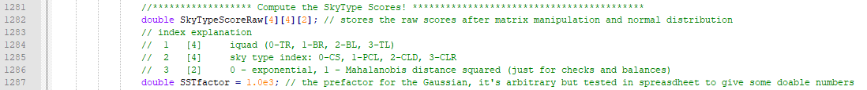

*9-19-18 done and works for skytype.*

* 1. Compute the relative skytype score.



1. Design a reasonable output of the information. A skytype output file with a line for each single quadrant, for example. Perhaps, assign a single-word characterization (“PCL”) in one of the first columns.

## **Test Results for the Halo Score in the test images**

Note 9-24-2018: After color correction was implemented, haloscore1, using all 40parameters, has a 100% success rate! Redo for 40 parameters!

This work is done in the same excel spreadsheet as the skytype assignments above.

The main difference to the skytype assignments is the number and type of properties considered in the halo score.

I did four versions, differing in the types and numbers of properties I included in the scoring.

I will use the combination as found in haloscore5, which includes all the properties in the order in which they appear in the properties file (minus the doubles for cv and the stdevs, and not the explicit differences).

1. *B slope slope of the line fit in the blue channel*
2. *B intercept intercept of the line fit in the blue channel*
3. *B ARIvar standard deviation of intensity of the blue channel, averaged over analysis area*
4. *CV color value of the analysis area*
5. *B LocMaxDer radial location of the maximum of in the blue channel (steep upswing in η)*
6. *B LocPMDer radial location of subsequent sign change for derivative*
7. *B LocMinDer radial location of subsequent minimum of derivative*
8. *B ValMaxDer value of maximum of derivative*
9. *B ValMinDer value of minimum of derivative*
10. *B nmax number of maxima in η identified in the analysis interval of the blue channel*
11. *stdLMaD standard deviation between the color channels of LocMaxDer*
12. *stdLPMD standard deviation between the color channels of LocPMDer. That is the location where changes sign, corresponding to the radial position of the brightness maximum.*
13. *stdLMiD standard deviation between the color channels of LocMiDer. That is the location where reaches a minimum after the maximum.*
14. *G slope slope of the line fit in the green channel*
15. *G intercept intercept of the line fit in the green channel*
16. *G ARIvar standard deviation of intensity of the green channel*
17. *G LocMaxDer radial location of the maximum of in the green channel (steep upswing in η)*
18. *G LocPMDer radial location of subsequent sign change for derivative*
19. *G LocMinDer radial location of subsequent minimum of derivative*
20. *G ValMaxDer value of maximum of derivative*
21. *G ValMinDer value of minimum of derivative*
22. *G nmax number of maxima in  identified in the analysis interval of the green channel*
23. *R slope slope of the line fit in the red channel*
24. *R intercept intercept of the line fit in the red channel*
25. *R ARIvar standard deviation of intensity of the red channel*
26. *R LocMaxDer radial location of the maximum of in the red channel (steep upswing in η)*
27. *R LocPMDer radial location of subsequent sign change for derivative*
28. *R LocMinDer radial location of subsequent minimum of derivative*
29. *R ValMaxDer value of maximum of derivative*
30. *R ValMinDer value of minimum of derivative*
31. *R nmax number of maxima in η identified in the analysis interval of the red channel*

The representative values for these variables are being collected. A covariance matrix and a vector of average values was computed.



For the constant, I am choosing  in order to discriminate halo images from other skytypes without halo.

In Figure 31, the distribution of resulting haloscores is shown for the five categories of sky images contained in the fitting set. If F>1.0, the confidence is very high that a halo is present. Between 10-5 and 1.0, other skytypes might yield a value ofr F, but still, the majority will be halo-bearing. No halo images have an F lower than 10-7. So, this should work. With proper training of the master file, I should be able to make this work for a wide variety of halo images.

Figure 31. Distribution of haloscores for the test images. I used a prefactor of 1.e-6 for the Gaussian scaling.

**How to implement this magic halo score?**

1. Import the vector of averages (M vector) and the inverse covariance matrix for these variables.
   1. Definitely create a separate spreadsheet to collect more example data and continue refining the matrices and averages as the computations progress.

*09-18-2018 done, see section 4.10.*

*09-26-2018 redo this for 31 variables. New master file for the matrix import:*

*G:\haloloop\src\Haloloop-SkyType-HaloScore-Master.xlsx*

*M vectors and inverse covariance matrices can be directly copied from there in *-haloloop-in-prms.txt.*

*Successfully created the 31 by 31 matrix. Testing in G:\haloloop\test\parameter-testing\RAtesting\haloloop-out-PropertyLog-sorting.xlsx*

* 1. Allow to directly use the numbers from the spreadsheet in the running of haloloop.

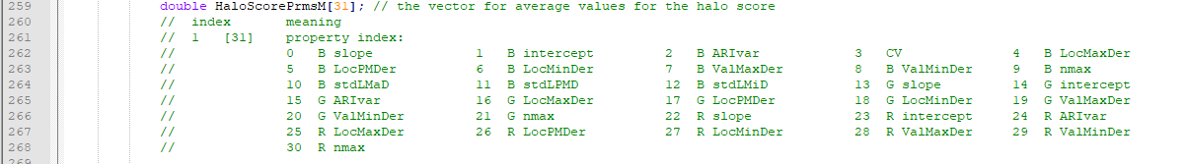

1. Compute the 31 variables for each quadrant, and perhaps store them in an appropriate array.

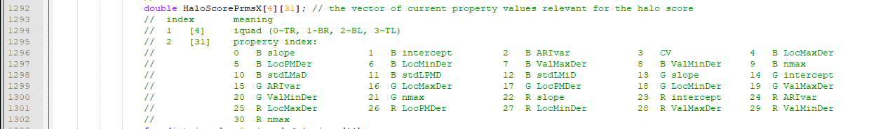

*Done. This vector is ready.*

1. Compute the Mahalanobis distance for each quadrant. Compute F for each quadrant

*Done in line 1452.*

1. Compute the haloscore.



1. Flag the quadrant with a HAL marker if confidence that halo might be present.

*Instead, I am assigning an overall score and a HAL/hal/--- marker.*

1. Consider to export a list of only the HAL images during a run.

All flagged mages are noted in separate halolog file.

## **The haloloop-scoring table**

I created a spreadsheet, that will be iteratively improved by adding the property lines for more images of each skytype and halo type.

This file is kept in the src directory for halo loop:

I:\haloloop\src\Halolopp-SkyType-HaloScore-Master.xlsx

This file will be stored together with the source code of haloloop, and serve as an iterative learning tool to train haloloop to better recognize skytypes and halo presences. The file contains five property tabs. That includes one tab for each skytype and a tab for halo images. The content of these tabs are lines directly copied from the output of haloloop's *-out-PropertyLog.csv. As more files are analyzed, these lists will be complemented by more lines as skytypes are being processed, allowing for an iterative improvement on skytype and halo scoring. Edit these by pasting lines for archetypical quadrants directly into the tab. The new data will refine the parameters for skytypes and halo scores immediately.

A second type of tab contains the M and Covar information for skytypes and halo scores. These are computed data, ready to export into a csv file that will be read by haloloop. Every segment is set by default to use 2000 lines from the property tabs, however, all the computations will only use entry fields that contain data. That allows this training file to be flexible and to grow with experience. These tabs contain the best SkyTypePrms and HaloScorePrms availabe at the time of run. Never edit these tabs, however, export their content appropriately at the beginning of runs.

The third tab species is an intermediate computation step. It contains the covariance matrices themselves, and should not need to be changed as the data evolve.

A detailed description of haloloop and the importance and use of these data can be found in I:\haloloop\doc\Haloloop2018-development notes.docx

The basis of the data comes from the 80 sample files in I:\haloloop\test\parameter-testing and are gathered in \haloloop\test\parameter-testing\RAtesting\haloloop-out-PropertyLog-sorting.xlsx



|  |  |  |
| --- | --- | --- |
|  |  | Please paste lines from propertyLog into these tables to refine and develop the parameter base for sky recognition. |
| **CS** | **cirrostratus** | Sky is milky with variations, but now sharp cloud outlines; Sun position is clearly visible; a halo may be present in the image (sun and cirrostratus) (contains the orginal Hal and CS data, but that distinction has been abandoned after testing) |
| **PCL** | **partly cloudy** | a variable sky with distinct low clouds and blue sky; analysis area contains sharp cloud outlines; often great variation between the sky quadrants of the LSM; solar position may or may not be clearly visible in the image |
| **CLD** | **cloudy** | sky is covered, low light; sun is completely obscured. |
| **CLR** | **clear** | blue, cloud-free sky; sun position is clearly visible; no sharp cloud outlines within the analysis area of the LSM |
| **HAL** | **halo** | A halo is visible around the sun. Often, this skytype will be of CS, but sometimes it may be PCL or CLR. This particular data set is only used to assign the halo score, so it is reserved for only halo-containing images. |

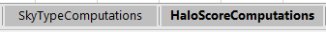

|  |
| --- |
| Never edit these. |
| These tabs contain the covariant matrices, selectively arranged for either the set of skytype properties or haloscore properties. |

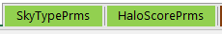

|  |  |
| --- | --- |
|  | These are for export to be read during haloloop runs. Export them as MS-DOS csv. |
| **SkyTypePrms** | contains the average vector M and the inverted covariance matrix S^(-1) for each skytype. There are for sequential (M, S) combinations. Uses 11 of the properties. Select the section of the work sheet within the bold frame. Ctrl-C and then Ctrl-V into the prm input file for haloloop. This will also preserve a record of the timing of the version, as well as the number of records used to groom the sky types. |
| **HaloScorePrms** | contains the average vector M and the inverted covariance matrix S^(-1) for HAL files only, using 28 of the properties. Select the section of the work sheet within the bold frame. Ctrl-C and then Ctrl-V into the prm input file for haloloop. This will also preserve a record of the timing of the version, as well as the number of records used to groom the sky types. |

Important: Improve the scoring by continuing to add propertylog lines into this file. All matrices and averages are preset to take in up to line 2000 in each worksheet – so have at it!

Take care to only copy “good lines”:

1. Paste into the correct category. Always make sure visually.
2. You need to resolve this by quadrants! Always inspect the actual image before adding new lines. Remember, this file forms the gold standard for all images.
3. Never paste lines with invalid fields, such as slopes of 1000, or missing data, or zeros where zeros do not belong.
4. Remove N/A quadrants as may occur when the sun is low.

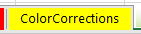

I also include the table of color correction values in this master file. The color corrections are steady over large portions of dates, but not across geographical locations. Hence it is helpful to simply gather them and re-use them.

#### Refinements after running sgp/2018/201803

What am I looking for?

Did the skytype get recognized correctly for each image?

Is a haloscore > 1 indeed showing a halo in the image?

Are there halos that did not get recognized?

Draw property lines to refine the master file.

Open these spreadsheets:

1. 201803-list-haloloop-out-SkyTypeLog
2. 201803-list-haloloop-out-PropertyLog
3. Haloloop-SkyType-HaloScore-Master
4. A window with a view of the images (windows explorer)

Go day by day

|  |  |  |  |  |  |
| --- | --- | --- | --- | --- | --- |
| date | Skytype recognition | Halo present if HS>1? | Halo present and no score? | Lines taken? | remarks |
| 10-8-2018 | Good! | Use 0.05 | Running in sgp/201803 | List, list2, list3  Too many false halos fromcld and pcl skies. Need to include a dos to include the influence of subsequent image signals. | |
|  |  |  |  |  |  |
|  |  |  |  |  |  |

## **Halo DOS**

I will model this after a method we used in generating the continuous density of states from discrete states. The halo score is discrete and independent on surrounding scores – every image is assigned a number.

**Problem:** I get isolated, discrete haloscores for images without halos, often just single images that happen to generate a signal. For a real halo appearance, we see series of images with high haloscore. The halo DOS will introduce a relation to images before and after a current image, and thus sort out the false positives much better than the isolated discrete halo score can. Each local Gaussian can be cut off outside of 3w since it has decreased to less than a millionth of its central value.



*F*

*t*

*F*

*t*

*H*

*t*

*2w*

*6w*

Figure 32. Illustration of the Halo DOS. Top panel shows a distribution of haloscores. A Gaussian of half width w has been assigned to each isolated score. The Halo DOS is the sum of these Gaussians, thus favoring halo scores in series of images.

**How to incorporate this into haloloop:**

1. Create a buffer with 6w+1 lines. The half width w will be in integral units of images, a cutoff is chosen to be 3w on either side of center to count forward and backward from a current position. Time t will also be counted as integral units in the computation of the Gaussians.
2. The buffer must work forward and backward, like illustrated below. It will have to contain all the skytypelog info, including location, UTZ etc.

*Record of current image with F, fill with all the info*

i = 100 - BuffRange

i = 1

i = 100

This record is complete

*All other fields empty*

Dos += F exp(-(3w-i)2/(2w2)

*All other fields filled i-3w steps before*

Dos += F exp(-(3w-i)2/(2w2)

Origin, UTZ, image, AzimuthAngle, ZenithAngle, DOS, All-DomSky, Halo?, All-CS, All-PCL, All-CLD, All-CLR, All-N/A, …

*Next: Push this line to SkytypeLog*

i = 3w+1

*Next: migrate index*

i = 100+BuffRange = BuffTop

Figure 33. Sketch of the buffering to compute the halo Dos.

1. The buffer will actually be a group of vectors for each output variable, to accommodate the different types of variable. I do not have the skill to use a class (which really would be the best thing to do here).

*String BufferString (6w+1)(2) to contain location, UTZ, imagename, angles formatted for csv in (0) and (1)*

*Double BufferDOS(6w+1)(5) allsky dos, and one for each skyquarter*

*Double BufferString2)(6w+1) exactly the same line as currently directly written out, formatted csv and \n*

10-9-2018 declared here:

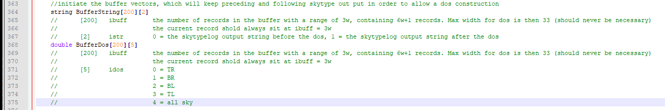

1. So, in each image step:
   1. Compute all the skytype and halo scores
   2. Check if new buffer needs to be initialized:
      1. If a new time series started reset buffer (morning)
   3. Write at position I = 3w of the current buffer
   4. Add the appropriate values of the Gaussian for F (all sky and each quadrant) to the dos between i=0 and i=6w+1
   5. Now write the buffer content at 6w+1 to the skytype log file.
   6. Move all buffer content to the next-higher index.
      1. Exceptions? – think this through
   7. The empty initial line receives zeros to initiate the newly to accumulate dos

(Implemented October 9. 2018)

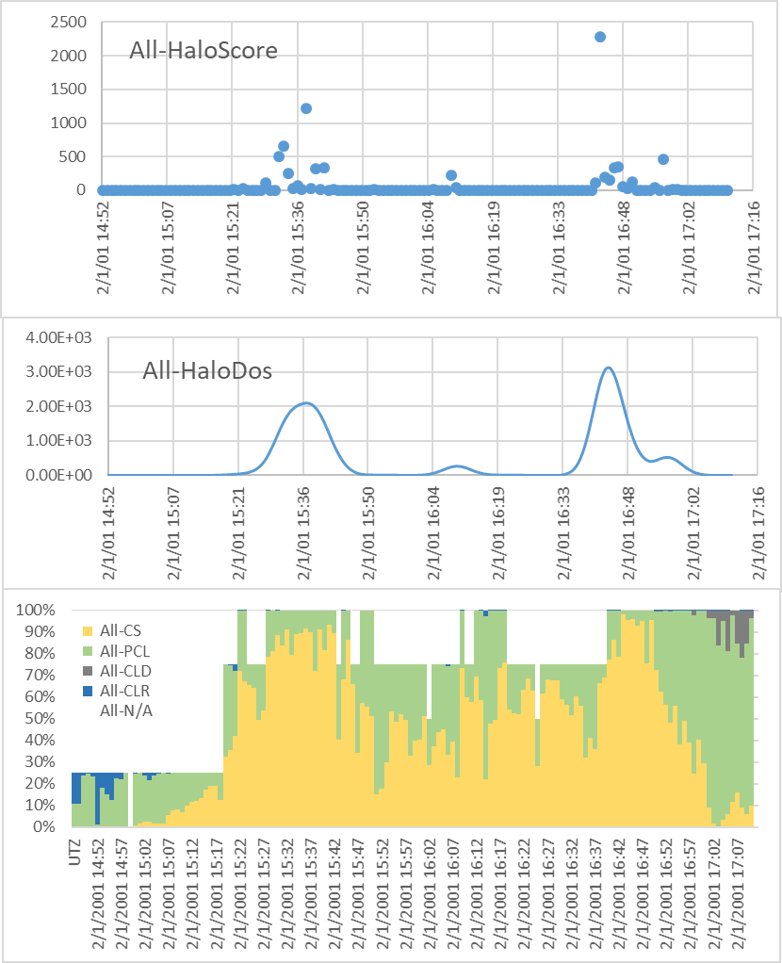

Figure 34. Sky analysis for test series SGP, 2001, Feb 1. Top panel: individual halo scores of images. Center: halo scores broadened across time series. Bottom: sky types in near-solar sky region; the white areas correspond to quadrants in which such a determination was not possible, either due to large zenith angle or over exposure. Halodos visually consistent with images. The data are located in haloloop/test/Feb2-2001sgp-list-haloloop-out-SkyTypeLog.xlsx

# **Data Collection**

## **TSI images**

The TSI images are organized by location, year-day-hour-min-sec, in folders on Allskylog4.

|  |  |  |  |  |
| --- | --- | --- | --- | --- |
| Abbr | Where | begin | end | Links to facility |
| NSA | **NORTH SLOPE OF ALASKA**  Central location:  71° 19′ 22.8″ N,  156° 36′ 32.4″ W  Start year: 1996 | 2006-04-25 | 2018-04-11 | <https://www.arm.gov/capabilities/observatories/nsa>  <https://www.flickr.com/photos/armgov/sets/72157623930532565/> |
| ENA | **EASTERN NORTH ATLANTIC**  Central location:  39° 5′ 29.76″ N,  28° 1′ 32.52″ W  Start year: 2013 | 2013-10-01 | 2018-05-29 | <https://www.arm.gov/capabilities/observatories/ena>  <https://www.flickr.com/photos/armgov/28109852724/in/album-72157629622837705/> |
| SGP | SOUTHERN GREAT PLAINS  Central location:  36° 36′ 18″ N,  97° 29′ 6″ W  Start year: 1993 | 2000-07-02 | 2018-05-29 | <https://www.arm.gov/capabilities/observatories/sgp>  <https://www.flickr.com/photos/armgov/sets/72157623930532361/> |
| Oli | Olikiok Point, Alaska  70° 29’ 42’’ N  149° 53’ 9.6’’ W |  |  | <https://www.arm.gov/capabilities/observatories/amf>  <https://www.arm.gov/research/campaigns/amf2015erasmus> |

My inclination would be to do one month at a time.

## **How to prepare a set of TSI images for a data run**

1. Change directory to the target month.

*i.e. G:\ARM-downloads\SGP\2018\201804*

1. Create a directory named *calibration*.



1. Copy a clear-sky image (sun visible) from about every 3 days of that month into the calibration folder. About 10 images.

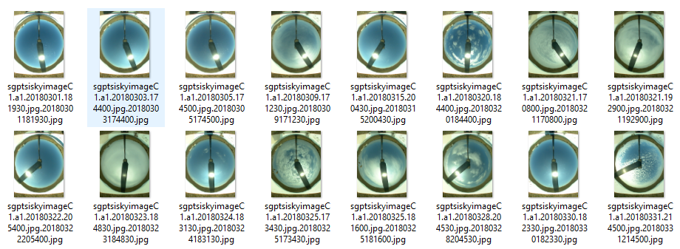

1. Now edit a haloloop-in-prms.txt file to calibrate the images of this month properly.
   1. **Color Calibration:**

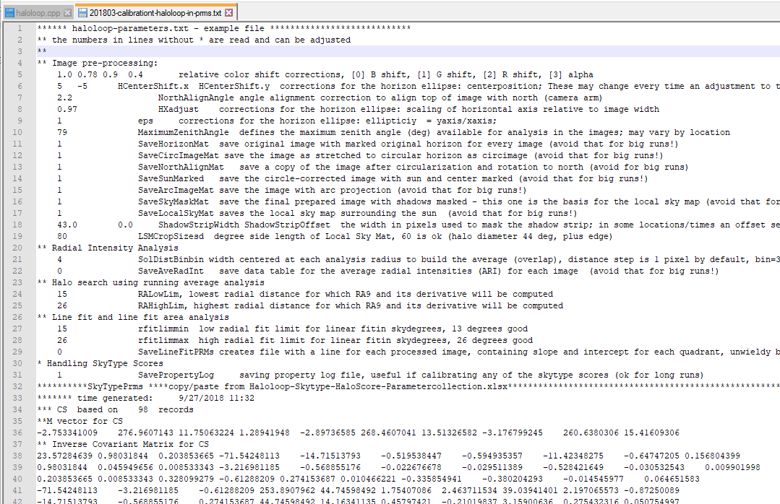

Use the Master file, color tab to see if this location and time frame already had been pegged for these values. If yes, use these values in this line. They represent the scaling factors for a clear blue piece of sky to scale the present BGR values such that the relative color values correspond to standard sky. B will always have value 1. The fourth number represents a scaling strength. If 0 no scaling is applied, if 1 all images are strongly tinted toward the target color ratios. Typically, a value between 0.1 and 0.4 seems to be adequate.

If no color calibration has been done before: Open a couple of clear-sky images in the folder and probe the BGR values in the upper right quadrant using a windows program like ColorPic.

Record the values in the master file and find a good series of color shift corrections for this location and time. Also record these in the Masterfile, since they are expected to be usable over larger sets of images than just one month.

* 1. **Orientation and View field calibration:**

Involves a series of numerical adjustments in the prms files, and subsequent execution of haloloop in which intermediate adjusted images are saved and inspected to correct the calibration values. For this step, set most of the SaveSomething parameters to 1 in order to get maximum feedback.



* Adjust HCentershift variables to center the horizon ellipse.
* Use HXadjust to scale the radius in horizontal direction as to align inside of the visible horizon.
* The variable “eps” adjusts the ellipticity of the horizon view.
* Next, decide whether a north-align angle is necessary. This will usually become apparent if the solar position (determined by time and geography) is not exactly aligned with the visible position of the sun in the image.
* The maxmum horizon angle allows to cut off horizon pieces that contain objects or are otherwise obstructed. It also often allows to scale the zenith position correctly.
* Last, adjust the shadowstrip characteristics.



* LSM CropSized does not need adjustment.
  1. **Other Parameters:**

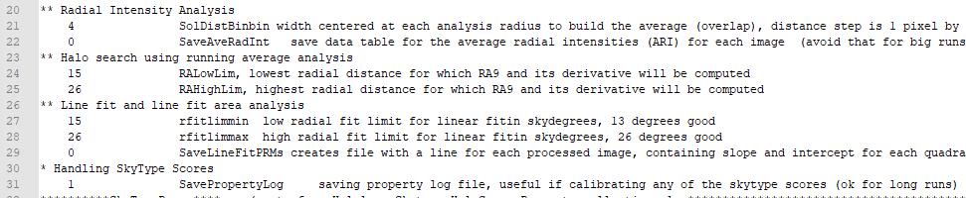

These do not need adjustments in general, since these need to be consistent with the settings used when the Masterfile is produced.

* 1. **SkyType and HaloScore matrices**

These can be directly copied and pasted from the Masterfile. Only necessary if new lines have been added to the Masterfile.

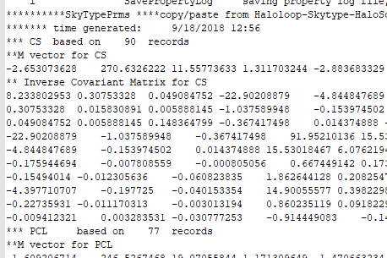 …

1. Generate the **calibration list**



1. **Run haloloop, a**nd check in all files for proper recognition of sky conditions, proper solar placement, proper color handling throughout the test images. If any of the calibrations vary through the month, make the appropriate decisions on the number of individual runs necessary.
2. **Set up for the big run:**
   1. Generate the file list



* 1. Copy the calibration prms file to the big run and change all the “1” foe SaveSomething to “0” (otherwise, too much diskspace will be taken and the program will take an exorbitant amount of time to finish).
  2. Run.
  3. Analyse.

## **Time line**

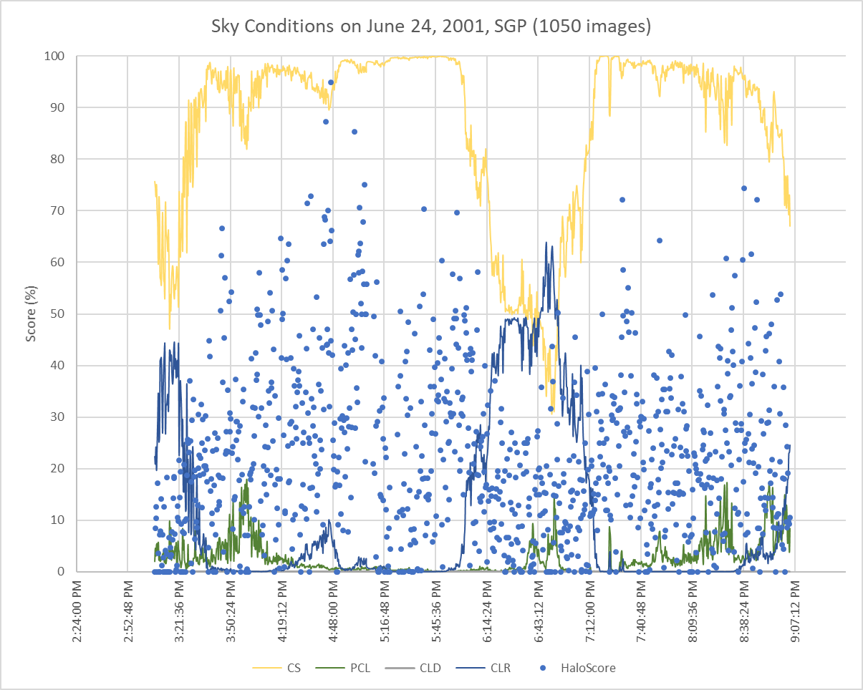

Figure 35. Example of a 6-hour period of consecutive all-sky images at the Southern Great Plains ARM site. There a clear ice halo visible in almost all images. The haloscore captures the fading and strengthening nicely! These data are located in I:\haloloop\test\jun24-list-haloloop-out-SkyTypeLog.xlsx.

1. N. Long, C., et al., *Retrieving Cloud Characteristics from Ground-Based Daytime Color All-Sky Images*. Vol. 23. 2006.